***Introduction to Robotics***

**Robot:-**A robot is a machine especially one programmable by a computer capable of carrying out a complex series of actions automatically. Robots can be guided by an external control device or the control may be embedded within.

* Robots are good substitute to human being in hazardous or uncomfortable work environment.
* A robot can perform continuous work with consistency and repeatedly which is quite difficult for human being.
* Robots can be reprogrammed.

**Three laws of robotics:-**

**1.** A robot may not injure a human through inaction, allow a human to come to harm.

**2.** A robot must obey the order given by human beings, unless such order would conflict with the first law.

**3.** A robot must protect its own existence, as long as such protection does not conflict with the first and second law.

**Robot anatomy and related attributes:-**

# Robot anatomy is the study of different joints and links and other aspects of manipulator’s physical construction.

# A robotic joints provides relative motion between two links of robot.

# Each joint is connected to two links; Input link and output link.

# Most of the robots are mounted on a stationary base.

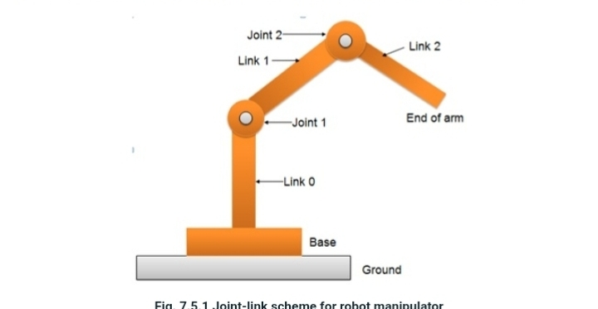

The robotics base and its first joints are termed as link 0.

* The first joint in the sequence is joint 1.
* Link 0 is the input link for joint 1 while the output link for joint one is link 1 which deals to joint 2.
* Thus link 1 is simultaneously the output link for joint 1 and the input link for joint2
* The end part of the link is known as end of arm.

**Types of joint:-**

1. Linear joint

2. Orthogonal joint

3. Rotational joint

4. Twisting joint

5. Revolving joint

1. ***Linear joint:-*** The relative moment between the input link and output link is a translational sliding motion with the axis of two links being parallel.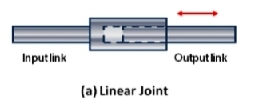
2. ***Orthogonal joint:-***This is also a translational sliding motion, but the input and output links are perpendicular to each other during the move.

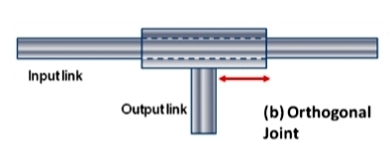

1. ***Rotational joint:-***This type provides relatives rotational motion, with the axis of rotation perpendicular to the axis of input and out put links.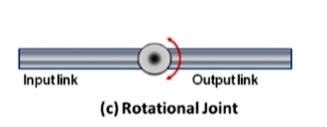
2. ***Twisting joint:-***This joint also involve rotary motion but the axis of rotation is parallel to the axis of two links.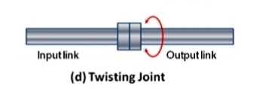
3. ***Revolving joint:-***In this type axis of input link is parallel to the axis of rotation of the joint. However the axis of output link is perpendicular to the axis of rotation.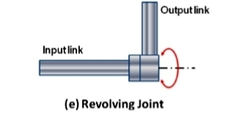

**Common robot configuration:-**

Basically the robot manipulators has two parts

(a) Body and arm assembly

(b) Wrist assembly

* Again there are 5 common types of body and arm assembly.

1. Polar configuration

2. Cylindrical configuration

3. Cartesian co-ordinate robot

4. Jointed- arm robot

5. SCARA ***(SELECTIVE COMPLIANCE ASSEMBLY ROBAT ARM)***

***1. Polar configuration:-***It consists of a sliding arm L joint, actuated relative to the body which rotates around both the vertical axis (T-joints) and (R-joint).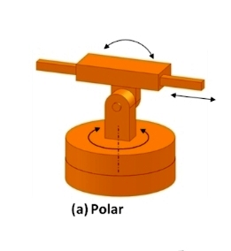

***2. Cylindrical configuration:-***It consists of a vertical column.

An arm assembly is moved up or down relative to the vertical column.

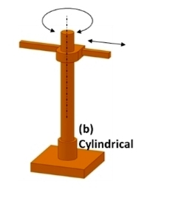

***3. Cartesian co-ordinate robot:-***It is also known as rectilinear robot and X-Y-Z robot. It consists of three sliding joints, two of which are two orthogonal O joints.

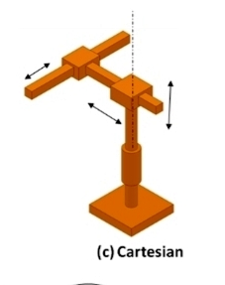

1. ***Jointed- arm robot\***It is similar to the configuration of human arm. It consists of a vertical column that swivels about the base using a T joint. Shoulder joint is located at the top of the column. The output link is an elbow joint.

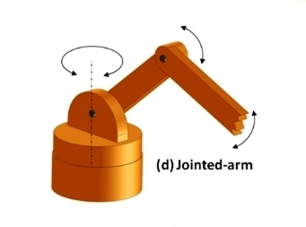

1. ***SCARA(SELECTIVE COMPLIANCE ASSEMBLY ROBAT ARM)***

Its full form is Selective Compliance Assembly Robot Arm.

It is similarly constructed to the jointed arm robot except the shoulder and elbow rotational axis is vertical. That means the arm is very rigid in vertical direction.

**Drive system:-**

1. Electric drive system

2. Hydraulic drive

3. Pneumatic drive

1. ***Electric drive system:-***

* Electric motors are the prime movers in robot.
* It is used in sophisticated industrial robot as well as in commercial applications.

1. ***Hydraulic drive:-***

* Hydraulic drives are used to accomplish linear motion and rotary motion of joints.
* It is generally used where larger speed is required and also to carry out heavy duty operations using tools

***3. Pneumatic drive:-***

* Pneumatic drives are used to accomplish linear motion and rotary motion of joints.
* It is normally used for simpler, smaller robotic application.

